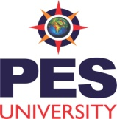

DEPARTMENT OF SCIENCE AND HUMANITIES

( Session : January – May 2016 )

PROJECT REPORT

ON

Submitted by

1. 01FB15

2. 01FB15

3. 01FB15

4. 01FB15

5. 01FB15

6. 01FB15

Program : B. Tech - CV

Semester : IV

Section :

PROJECT EVALUATION

( For Official Use Only )

|  |  |  |  |
| --- | --- | --- | --- |
| Sl No. | Parameter | Max Marks | Marks Awarded |
| 1 | Thoroughness of Presentation | 1 |  |
| 2 | Clarity | 2 |  |
| 3 | Substance | 2 |  |
|  | Total Marks | 5 |  |

Name of the Evaluator :

Signature :